**Lesson 7 Demo 4**

**Configmap as Volume by using Deployment**

**Objective:** To create a Deployment with Configmap as a volume

**Tools required:** kubeadm, kubectl, kubelet, and etcd

**Prerequisites**: Kubernetes cluster must be set up with kubeadm, kubectl, and kubelet installed and tested. Some Pods, Containers, Services, etc. should be in place so that troubleshooting can be done on the existing cluster and its contents.

Steps to be followed:

1. Creating a configmap in a file named deployment-cm.yaml and attaching the volume to it
2. Creating an Httpd Deployment
3. Verifying the configmap state
4. Accessing and verifying the volume configmap
5. Creating a Deployment using the following command
6. Verifying the Pods and Deployment
7. Executing the following command to access the Pod and verify the volume

**Step 1: Creating a configmap in a file named deployment-cm.yaml and attaching the volume to it**

**vi deployment-cm.yaml**

**kind: ConfigMap**

**apiVersion: v1**

**metadata:**

**name: deployment-configmap**

**data:**

**# Configuration values can be set as key-value properties**

**database: httpd**

**database_uri: httpd://localhost:80**

**Step 2: Creating a configmap using the following command**

**kubectl create -f deployment-cm.yaml**

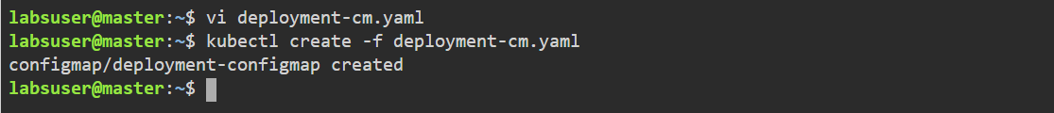

**Step 3:** **Verifying the configmap state**

**kubectl get configmap**



**Step 4: Creating an Httpd Deployment to attach a configmap as volume to it**

**vi deployment-volume.yaml**

**apiVersion: apps/v1**

**kind: Deployment**

**metadata:**

**creationTimestamp: null**

**labels:**

**app: myhttpd**

**name: myhttpd**

**spec:**

**replicas: 1**

**selector:**

**matchLabels:**

**app: myhttpd**

**strategy: {}**

**template:**

**metadata:**

**creationTimestamp: null**

**labels:**

**app: myhttpd**

**spec:**

**containers:**

**- image: docker.io/httpd**

**name: httpd**

**volumeMounts:**

**- name: config-volume**

**mountPath: /tmp/myenvs/**

**volumes:**

**- name: config-volume**

**configMap:**

**name: example-configmap**

**restartPolicy: Always**

**status: {}**

**Step 5: Creating a Deployment using the following command**

**kubectl create -f deployment-volume.yaml**



**Step 6: Ve****rifying the Pods and Deployment**

**kubectl get deployment**

**kubectl get pods**

**Step 7:** **Executing the following command to access the Pod and verify the volume**

**kubectl get pods**

**kubectl exec -it myhttpd-7cd6bd944f-dlp2k bash**

**root@myhttpd-7cd6bd944f-dlp2k:/usr/local/apache2# ls /tmp/myenvs/**

